Brandon Kmiec, Assignment 2, CSC 155 Section 2, Spring 2024

1. Screenshot of running program

1. Description of object created by hand
   1. The object that I created by hand was initially created for CSC 165. It is visible in the bottom right corner of the screenshot above. The object is an octagon shaped cylinder that is hollow on the inside. The object is made of 192 vertices and 64 triangles.
2. A description of which object(s) is moving, which object(s) is rotating, and which use tiling
   1. The moving object is the pyramid and it moves on the xy axis in an infinity shape.
   2. The rotating object is the complexCube located behind the xyz axes and it is rotating on the x and z axes.
   3. The objects with tiling are the cube in the bottom left of the screenshot and the hand created object in the bottom right of the screenshot. Instead of going back and manually changing each vertex to be outside the (0, 1) range, I used for loops to scale each vertex by a constant.
3. Requirements I was not able to get fully working
   1. On the camera controller, I was unable to implement the pitch and yaw movements without inducing a roll movement. Instead, I added key mappings to control the roll movement. Comma (,) rolls left and Period (.) rolls right.
4. Source for each texture and model used
   1. Wrinkled Page
      1. 
      2. Not made by me
      3. Obtained from <https://freestocktextures.com/texture/white-paper-sheet-wrinkled,1648.html>
      4. Creative Commons Zero License: <https://freestocktextures.com/license/>, <https://freestocktextures.com/support/>
   2. Ice
      1. 
      2. Not made by me
      3. Provided by the textbook
   3. Brick
      1. 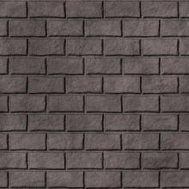
      2. Not made by me
      3. Provided by the textbook
   4. Custom Texture
      1. 
      2. Made by me using Microsoft Paint
      3. Originally made for CSC 165
   5. ComplexCube Imported Model
      1. 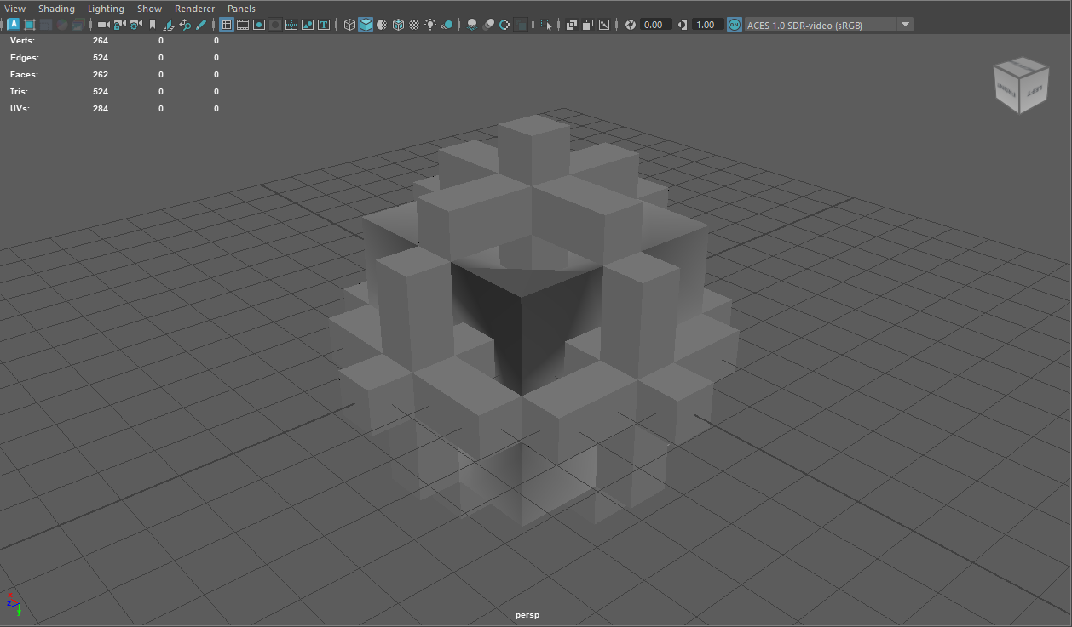
      2. Made by me
      3. Originally made in Maya for CSC126/ART142
5. Tested on RVR-5029 PONG